**Weather Service Report**

**Introduction:**

Open Weather is a team of IT experts and data scientists that has been practising deep weather data science since 2014. For each point on the globe, Open Weather provides historical, current and forecasted weather data via light-speed APIs. Headquarters in London, UK.

Open Weather API is a weather API that makes available weather data to the users by city name, state or state code etc. We will be using two API’s of Open Weather in this service. The first is simple weather API that will give us the weather data of current day of any city and state. The second is forecast API that will give us the weather forecasting data of upcoming days for the particular city.

**UML Diagram:**

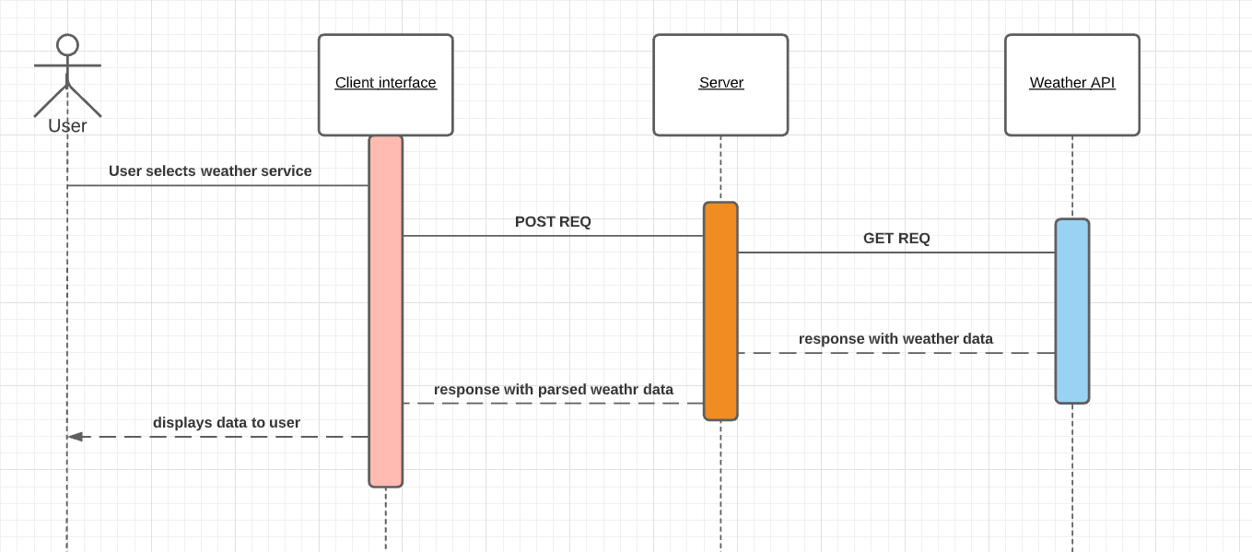

The above diagram represents the sequence diagram of the complete user-server-API interaction. The sequence diagram shows how the data is fetched from the API and parsed and sent back to the client interface which displays this data to the user in a format.

When the user selects the weather service and enters the city name and hit search, client interface makes an post request to the server and server makes get request to the API and in response the API sends the weather data to the server. The server then parse the data and collect the required data from the response and then render the page with this data as a response to client post request. This data is now visible to the the user in the client interface.

**Evaluation :**

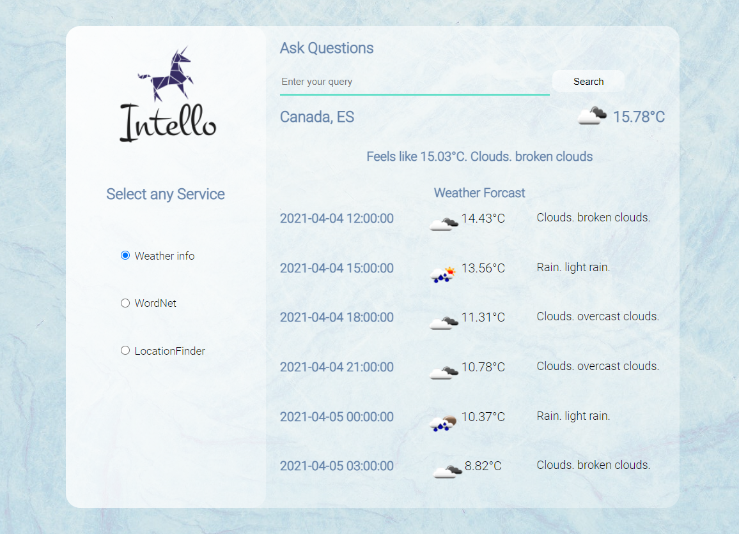

The above diagram shows how the data is represented to the user. The weather data of the current day is displayed at the top and the forecast data is displayed right below it. The forecast data shows the time, temperature and description of the weather at different days and time.

It was a great learning experience building this service. I got to learn how to access the API and parse data and extract relevant data of our needs then render it on the interface. I ran into a problem while developing this functionality. The problem was when I entered the city name and hit enter ,the data was not getting rendered on the screen and if I again hit enter then the data was getting rendered. After searching its cause in the server code I got to that this fetching and parsing of API data is taking some time but the server is sending response even if the data is not fetched yet. Then after trying different solution, I made the response to trigger only after specified amount of time is passed, so that the server would have ample amount of time to fetch and parse the data. Overall , it was a great experience.

**Client and Server Interaction:**

When the user selects the weather service and enters the city name and hit search, client interface makes an post request to the server and server makes get request to the API and in response the API sends the weather data to the server. The server then parse the data and collect the required data from the response and then render the page with this data as a response to client post request. This data is now visible to the the user in the client interface.

**References:**

[https://openweathermap.org/guide#:~:text=OpenWeather%20is%20a%20team%20of,Headquarters%20in%20London%2C%20UK.](https://openweathermap.org/guide%23:~:text=OpenWeather%20is%20a%20team%20of,Headquarters%20in%20London%2C%20UK.)